TECHNICAL PROJECT REPORT

# **Title of Invention / Project:**

***AUTOMATIC DOOR LOCK SYSTEM***

# **Team Members / Inventors**:

|  |  |  |  |  |  |
| --- | --- | --- | --- | --- | --- |
| **S. No.** | **Name** | **Department** | **Designation** | **Mobile** | **E-Mail** |
| 1. | RISHABH GUPTA | CSE IOT | LEADER | 9621069694 | rishabhguptaofficial2018@gmail.com |
| 2. | NITIN MEHRA | CSE IOT | MEMBER | 7500722710 | nitinmehra170@gmail.com |
| 3. | SAKSHAM RAI | CSE IOT | MEMBER | 9140812734 | saksham007rai@gmail.com |
| 4. |  |  |  |  |  |
| 5. | Khushal Thakur | ECE | Mentor | 9646030764 | khushal.thakur@cumail.in |
| 6. | Anshul Sharma | ECE | Mentor | 9478697475 | anshulsharma.ece@cumail.in |
| 7. | Kiran Jot Singh | ECE | Mentor | 9463909689 | kiranjotsingh.ece@cumal.in |
| 8. | Divneet Singh Kapoor | ECE | Mentor | 9878422653 | divneet.ece@cumail.in |

Section – 1 (IPR Related)

# **Brief Abstract:**

* **Problem our project is solving**

Many times the key breaks in the door. Another problem is that the key of the door won’t insert. Sometimes the door locks are slow. Major problem is when the lock is not working.

* **How are we solving that (solution)?**

It is fully automatic and it does not have a key to lock and unlock. Thus the problem of key broke is solved. You don’t have to insert the key because it is without a key. It works with your phone. You can control it with your phone app. Just install the app and connect it and enjoy.

* **Additional modifications that can cater to improved solution**

1. We can insert voice recognition to lock and unlock as an additional modifications.
2. We can also attach fingerprint recognition too.
3. We can install keypad password protection.

# **Existing state-of-the-art and Drawbacks in existing state-of-the-art:**

|  |  |  |
| --- | --- | --- |
| **S. No.** | **Existing state of art** | **Drawbacks in existing state of art** |
| 1 | DOOR LOCK | Not automatic. |
| 2 | KEY DOOR LOCK | Key can be lost. |

# **Novel/Additional modifications that you can propose to improve upon drawbacks:**

* **Feature 1**

We can install voice recognition and fingerprint recognition to ease our work.

* **Feature**

We can use wi-fi dongle in place of Bluetooth device because Bluetooth is short ranged.

# **Advantages:**

* **Adv 1**--It is automatic and wireless.
* **Adv 2**--It is cheap.
* **Adv 3**--It is easy to install and has a requires low maintenance.

# **Block Diagram:**

Section – 2 (Real Project)

# **Materials:**

1. **Arduino UNO-**

**Microcontroller-ATmega328**

**Operating voltage-5V**

**Input voltage-7-12V**

**Input voltage-6-20V**

**Digital I/O pins 14(6 of which provide PWM)**

**Analog Input Pins-6**

1. **Bluetooth module-HC-05**
2. **Jumper wires**

**Wire length=20cm**

**The male ends are meant for insertion into standard 0.1 inch female socket.**

**The female ends are meant for insertion into standard 0.1 inch male socket.**

1. **Adapter**

**Input: 100-270V AC-50/60 HZ**

**Output: 12V- DC 1 AMP**

1. **Servo motor**

**Company: Tower Pro**

**Micro Servo: 9g**

**SG90**

1. **Door lock**

# **Circuit Diagram:**

**THE CIRCUIT DIAGRAM IS SHOWN BELOW--**

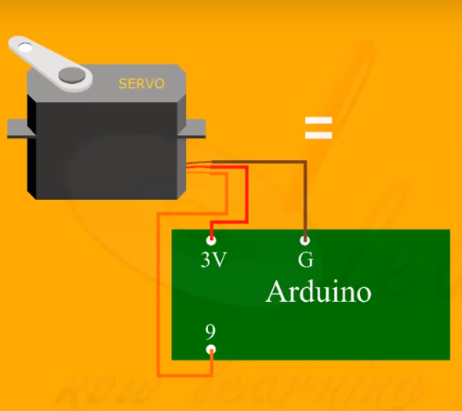

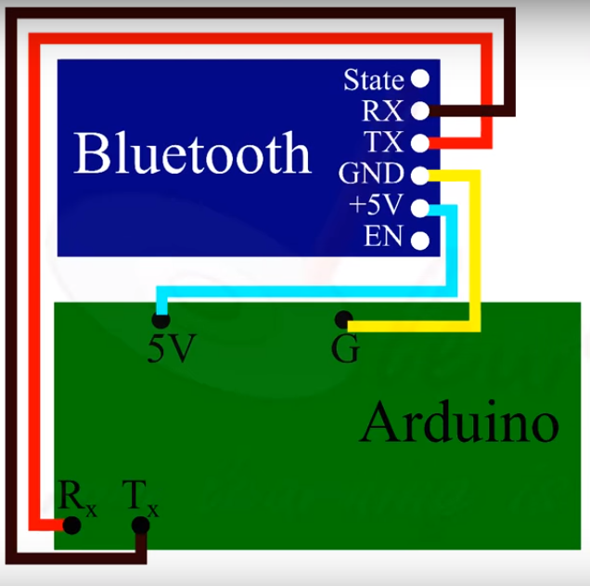

# **Steps of Circuit Completion:**

**The pictures of the components and the steps are as follows**:

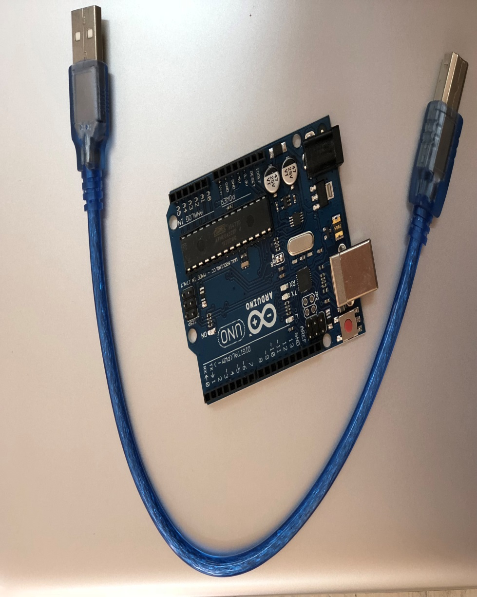

1. **ARDUINO UNO**

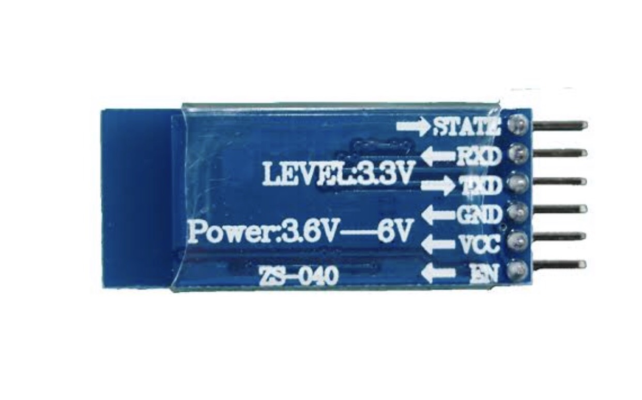

1. **BLUETOOH MODULE HC-05**

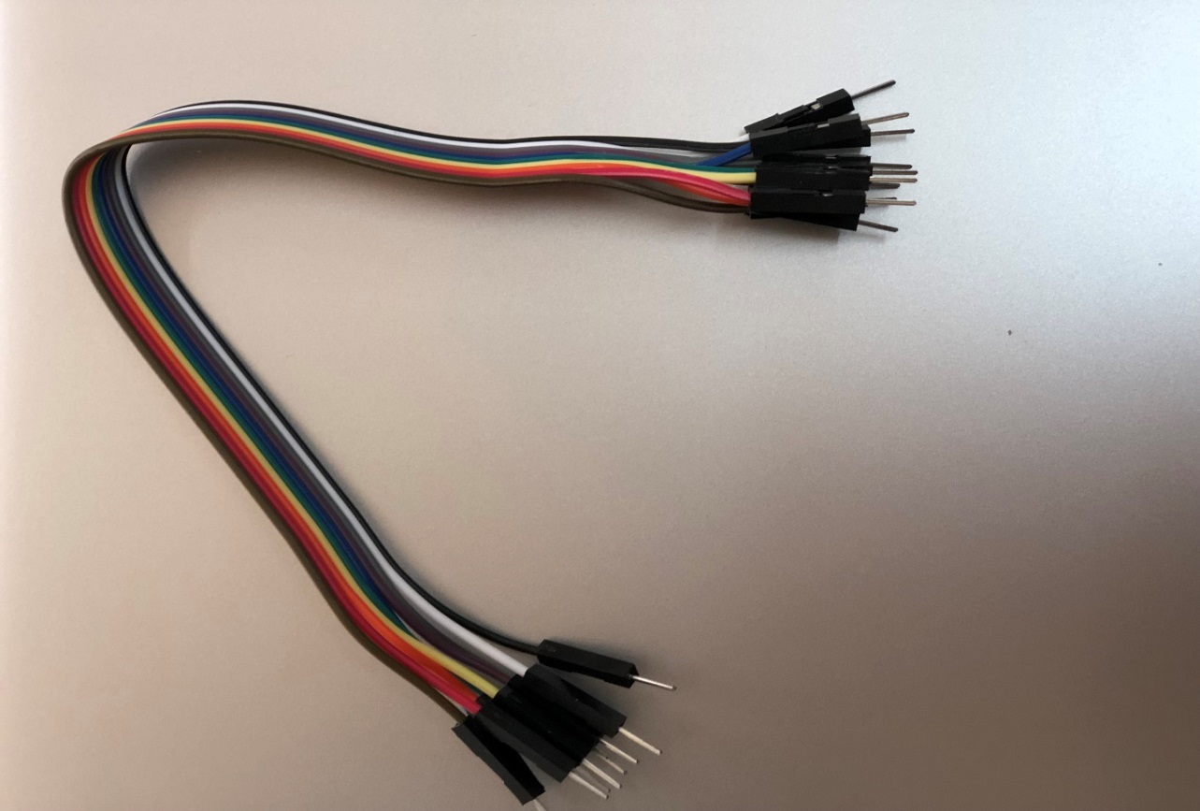

1. **JUMPER WIRES MALE TO MALE**

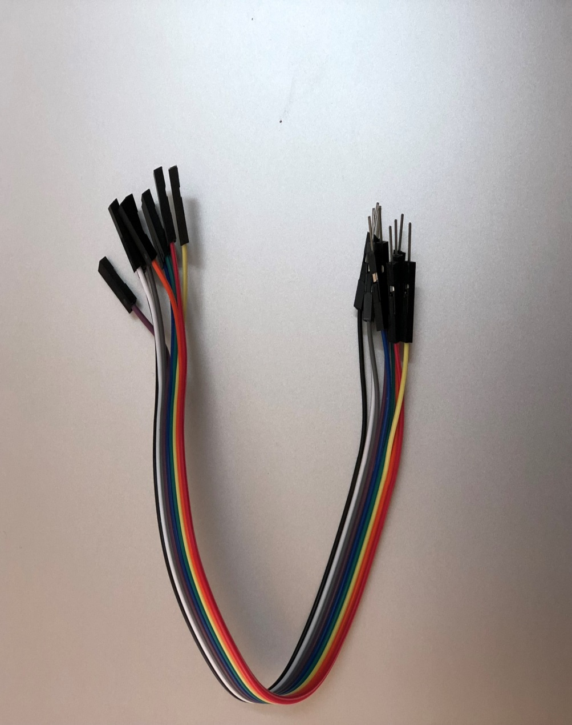

1. **JUMPER WIRES MALE TO FEMALE**

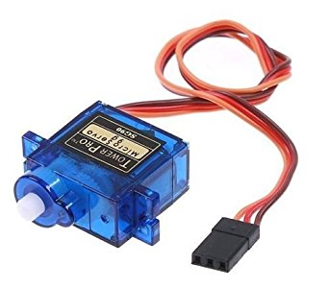

1. **SERVO MOTOR**

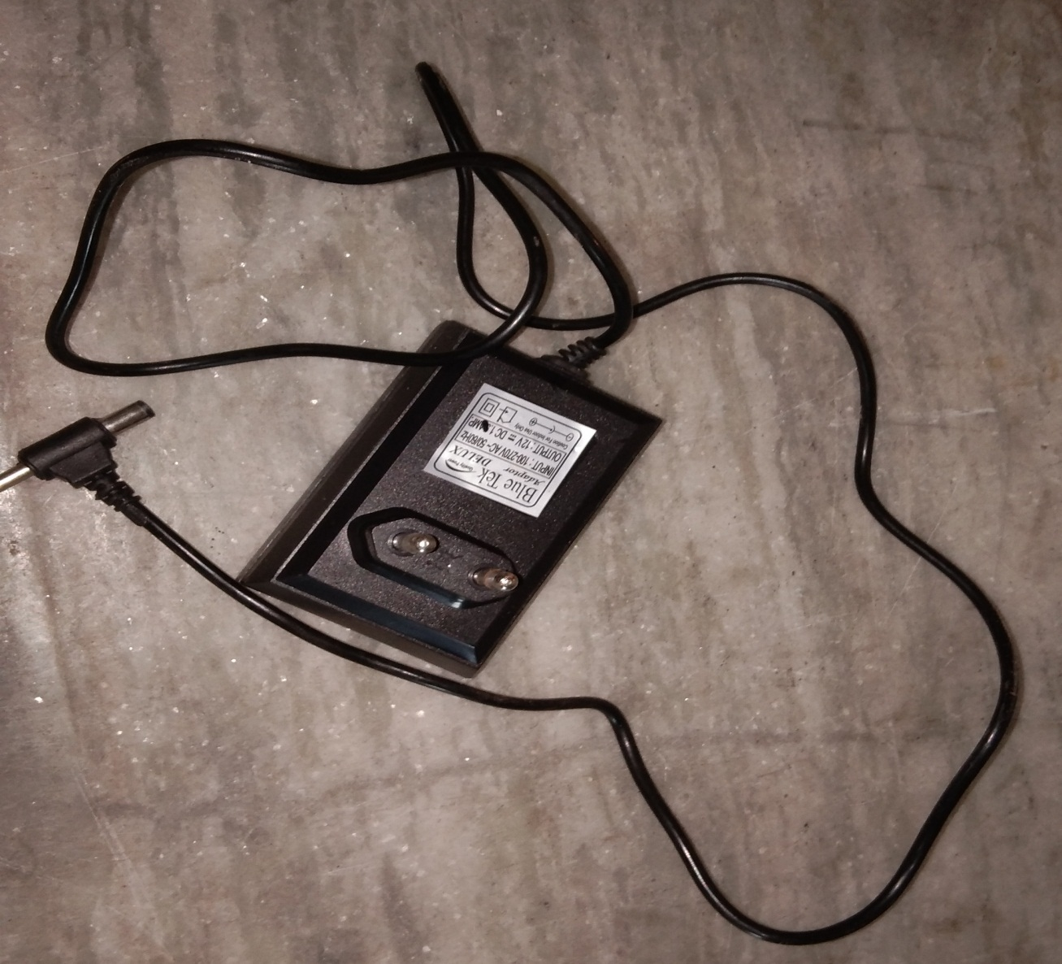

1. **ADAPTER-12 V**

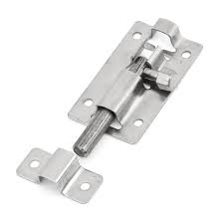

1. **DOOR LOCK**

**THE PICTURES OF STEPS ARE AS FOLLOWS:**

**PHASE 1: CONNECT MOTOR WITH ARDUINO UNO**

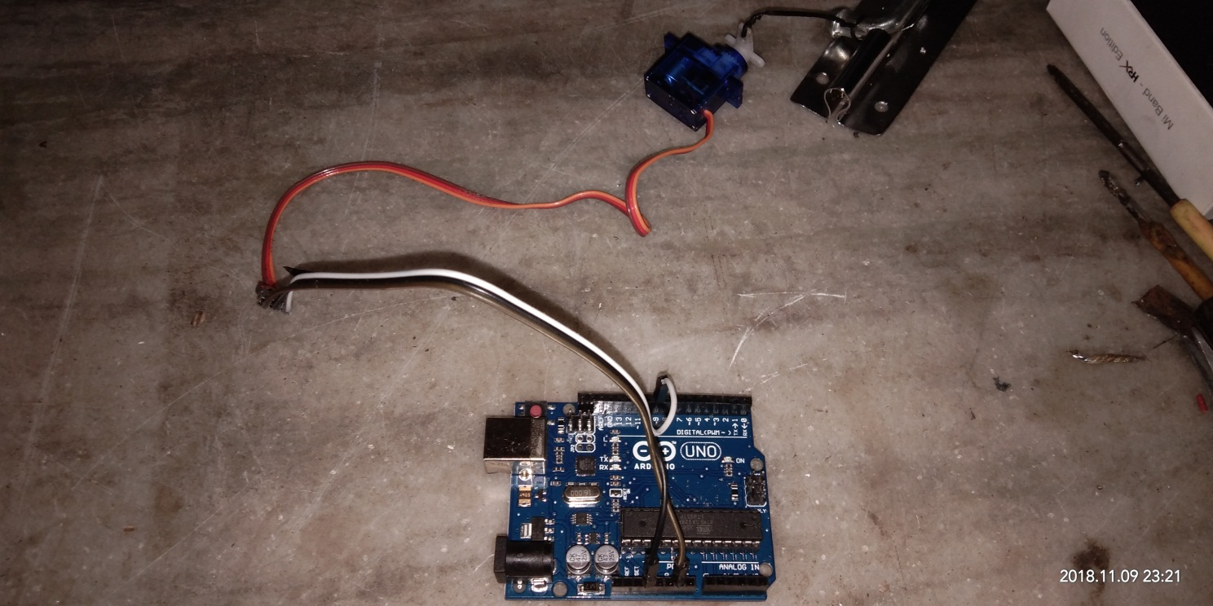

**PHASE 2: CONNECT BLUETOOTH WITH ARDUINO UNO**

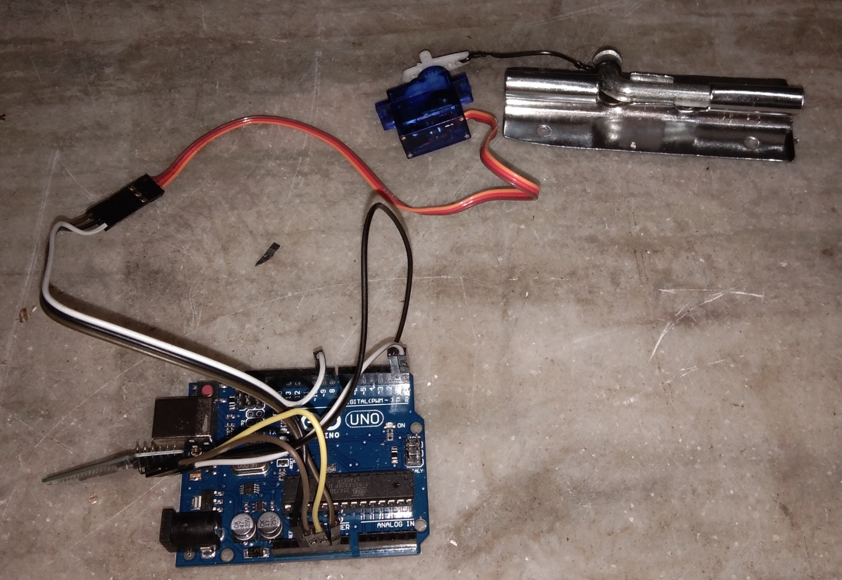

**PHASE 3: CONNECT ADAPTER TO THE CIRCUIT**

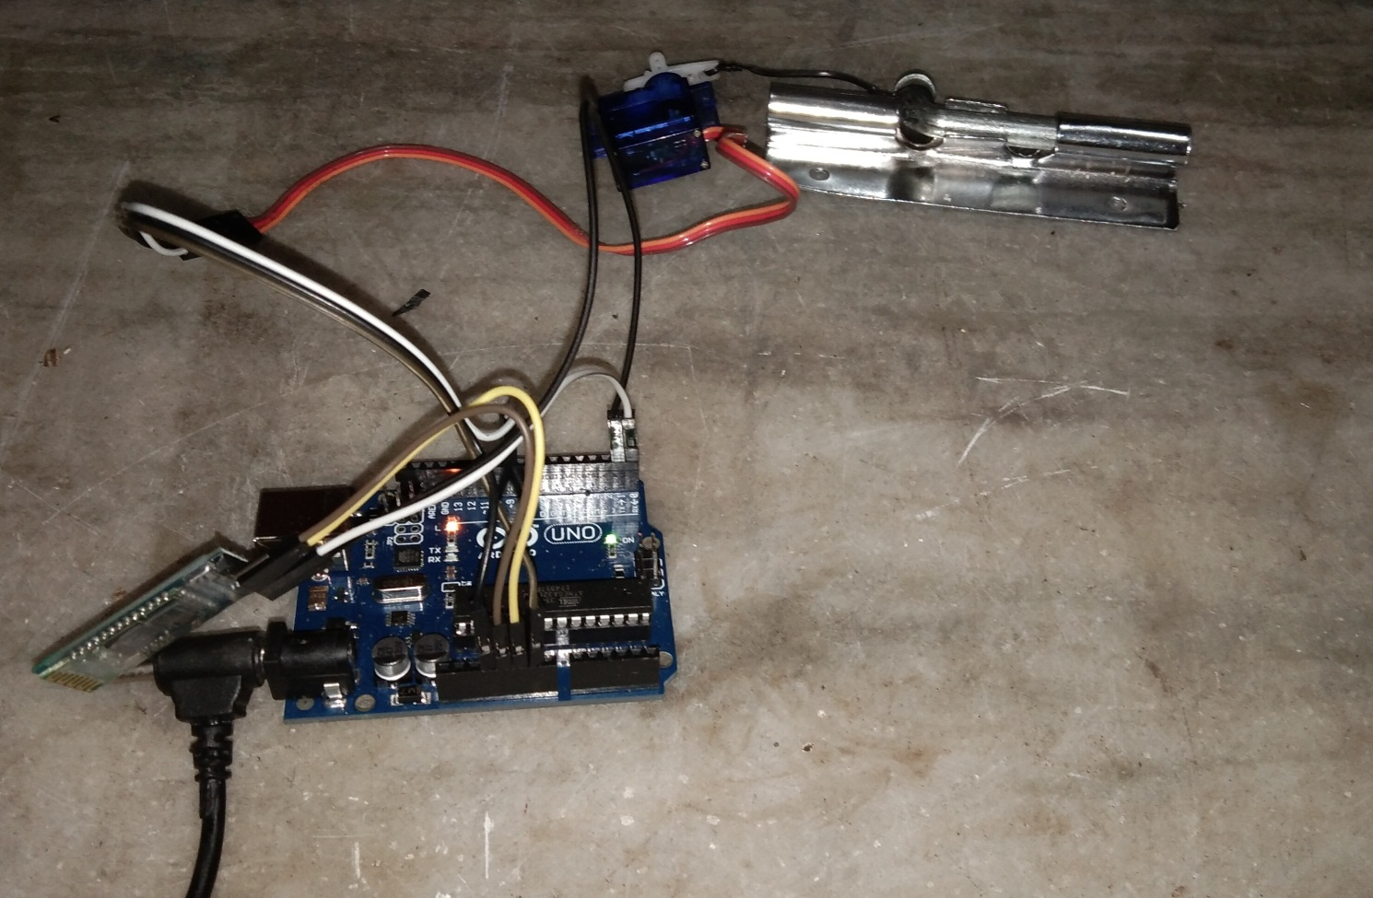

**PHASE 4: CONNECT ADAPTER TO MAINS 220VOLT**

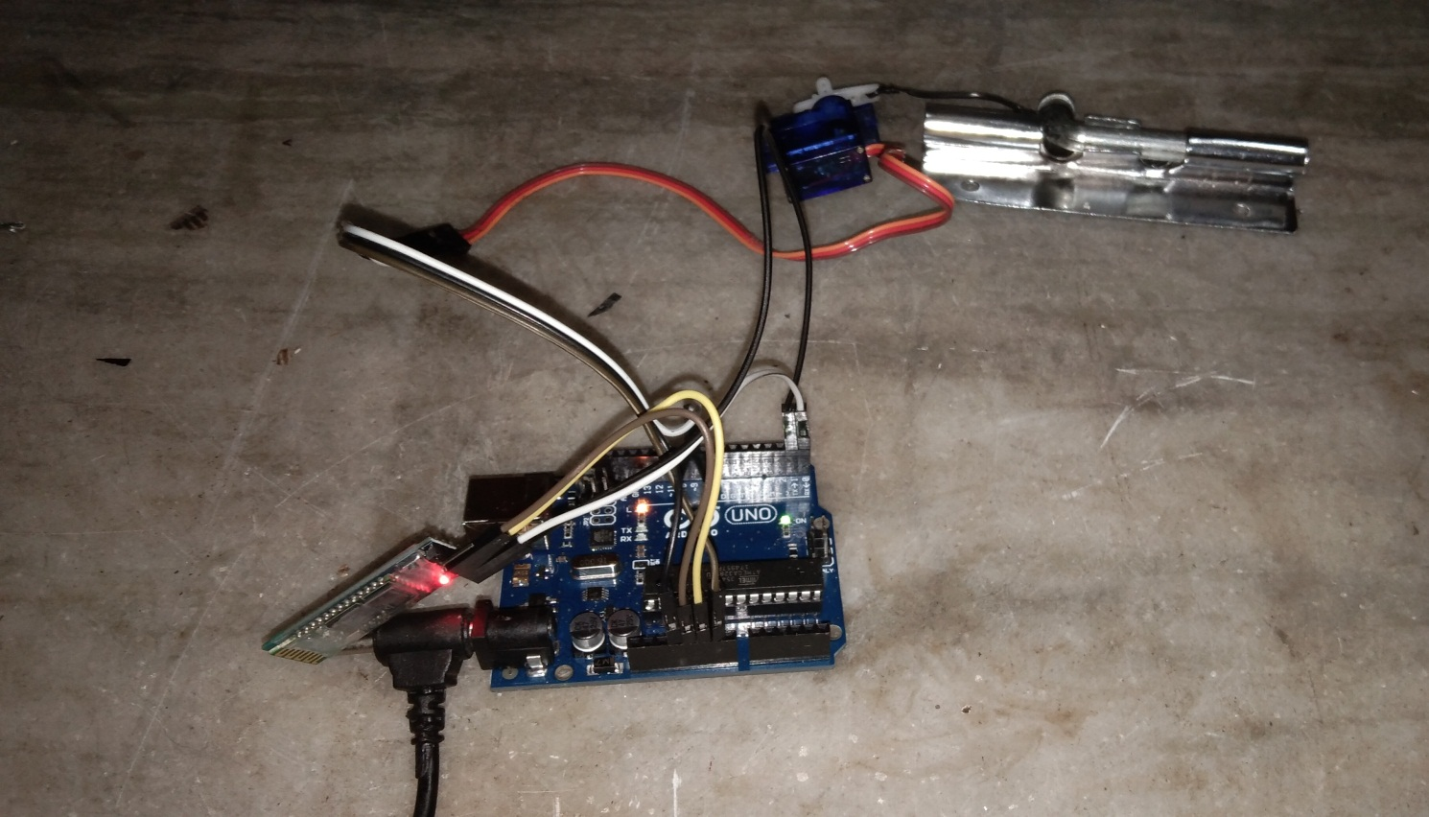

**PHASE 5: ASSEMBLE IT IN A BOX**

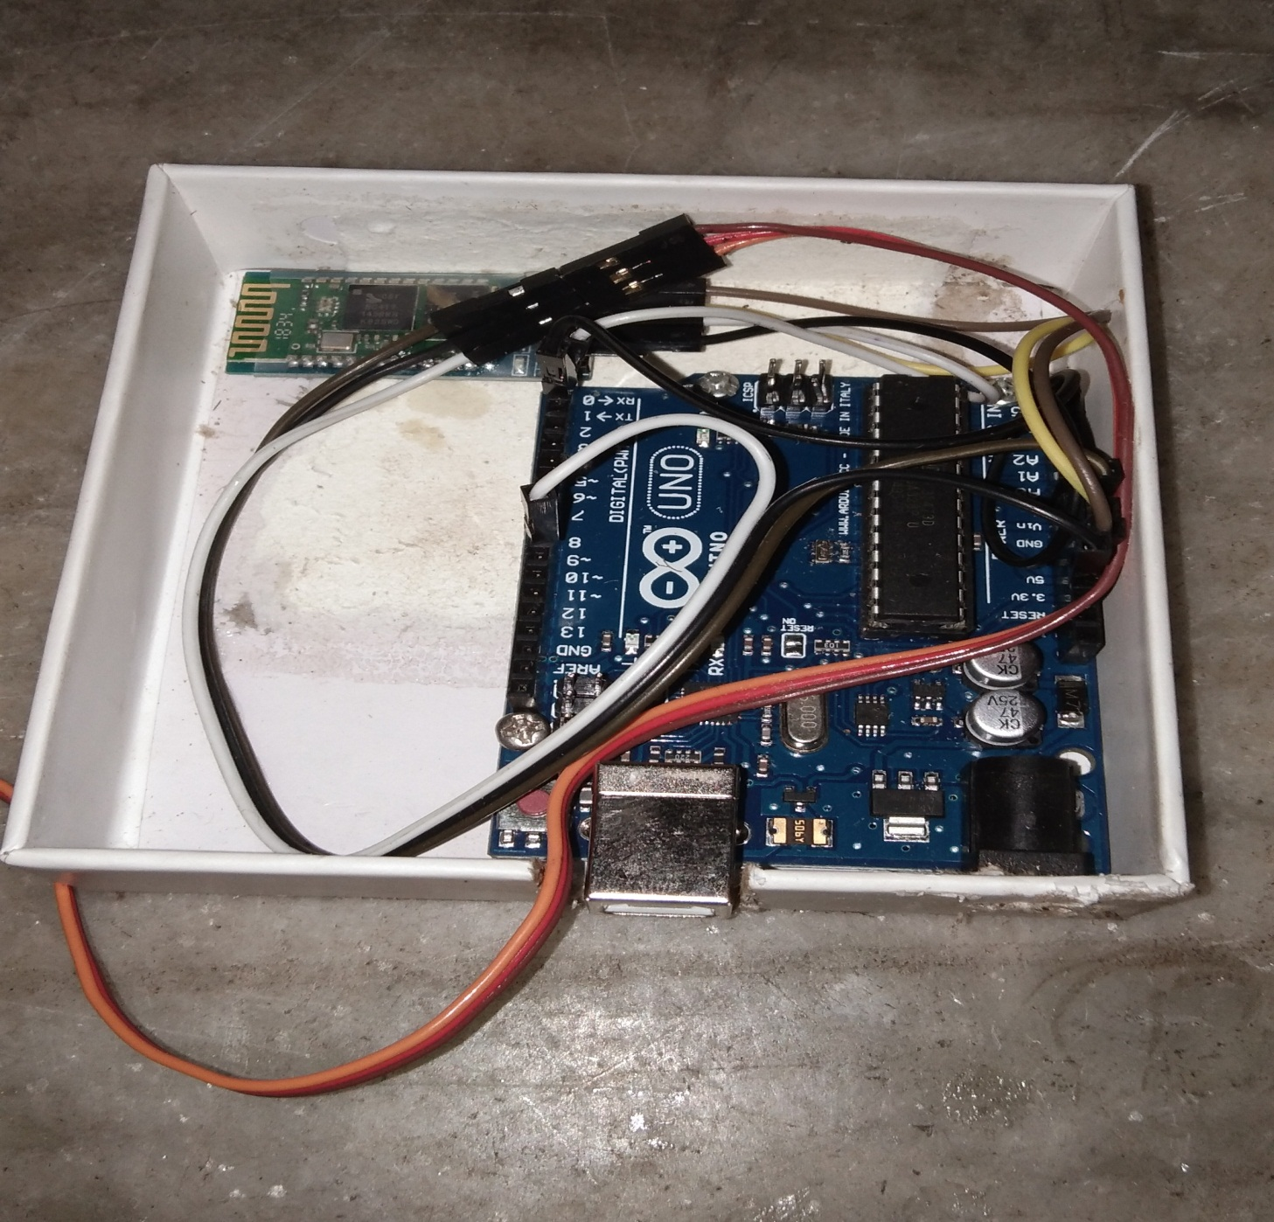

**INSTALL THE APP ON YOUR ANDROID PHONE**

**(LINK)---** **http://www.learnbywatch.com/download/4321/**

# **Program Code:**

**https://github.com/Rishabh4513**